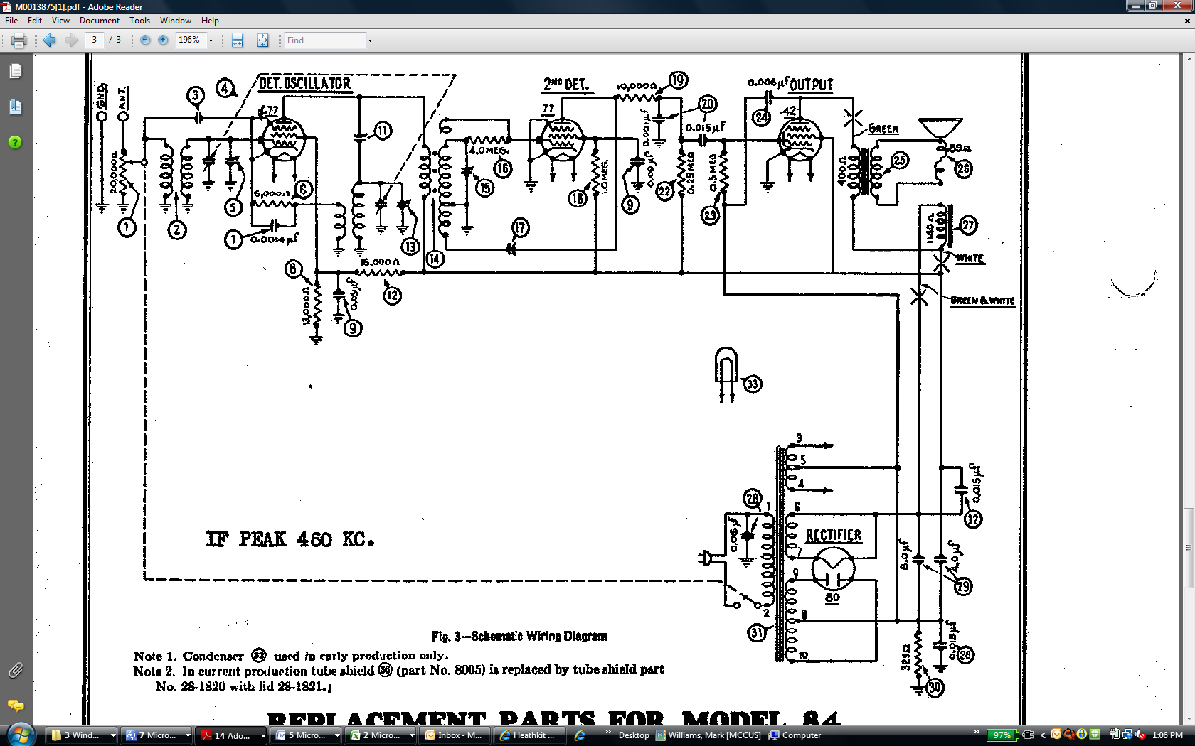 

Resistor or Choke ?

Speaker

42